GPGPU lab3 report R04943005 吳奕亨

Two level iteration 5000 5000 Jacobi itereation 7000

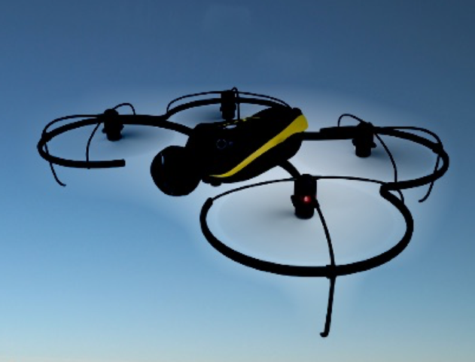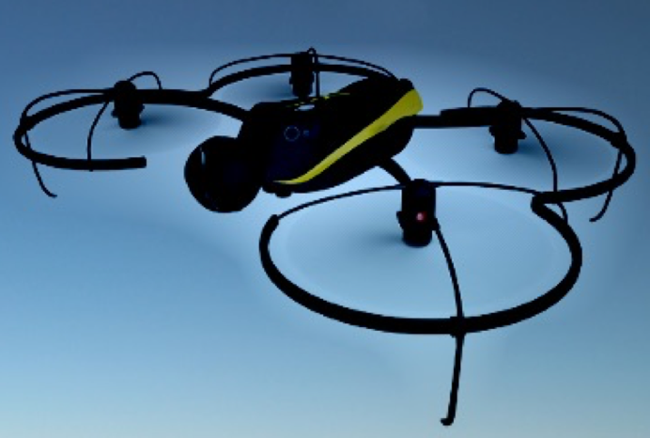Time: 1113215us Time: 1133688us